**City of Los Angeles**

**311 Call Data Analysis**

**Group 5**

Shawn Hardesty

Xinyu (April) Liang

Jinhong (Jino) Lu

Yang Lu

Patrick McDermott

# Introduction

The point of this project was to take large datasets from LA311 and visualize the data in hopes of finding patterns. Our group was able to find a couple unique outliers and patterns because of this. However, there were also a couple methods we tried that were not successful. This will outline what we did and what we recommend.

# Data Preparation

There are two original datasets for us to use. The first dataset is the tracking data, which contains 3,565,446 observations with 7 variables indicating different dimensions of one call into 311 center. The second dataset is the request data, which contains 1,082,579 observations with 33 variables; it is a more detailed version of information of each single request in the last two years.

When we received access to the datasets, what we did first was reorganize the dates and to break out each date into months, days, and weekdays using the lubridate function in R to make those variables analyzable for the heat map and other graphs in the datasets.

Also, we managed to obtain the California ZIP Code Data and California Population Density Data. After filtering with the Los Angeles area, what we did was merge the original datasets with ZIP Code Data and Population Density Data for the further analysis.

When it comes to missing values and “NA”, we did not drop all of them to keep the dataset integrated to the best extent possible; we just filtered and ruled out observations with “NA” and missing values when we generated graphs.

# Data Visualization and Interpretation

## 3.1 311 Call Center Tracking Data

### Number of Calls

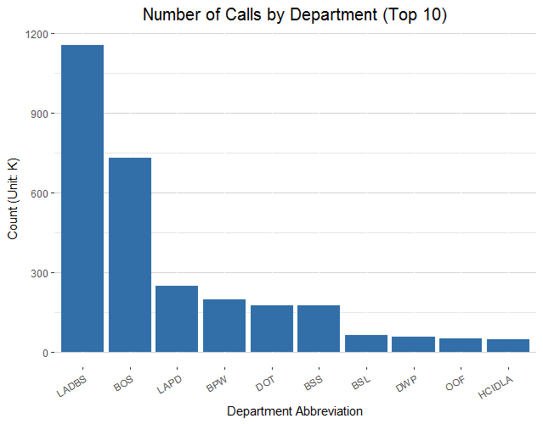

Figure 3.1.1 Number of Calls by Department (Top 10)

Figure 3.1.1 shows the number of calls associated with the top 10 departments. It appears that LADBS (LA Department of Building and Safety) has the highest number of calls, followed by BOS (Bureau of Sanitation), and LAPD (LA Police Department).

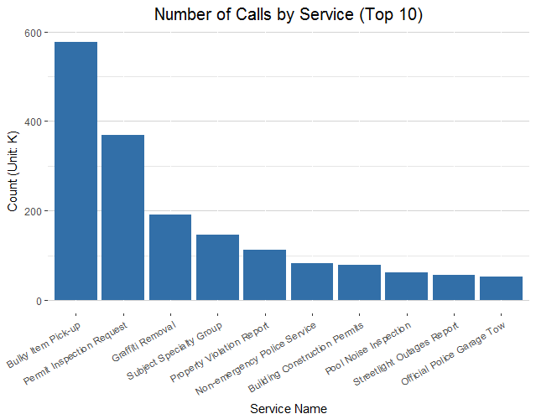

Figure 3.1.2 Number of Calls by Service (Top 10)

Figure 3.1.2 shows the number of calls associated with different services (only top 10 services are displayed in the graph). Among all the services, bulky item pick-up has highest demand, followed by request of permit inspection and graffiti removal.

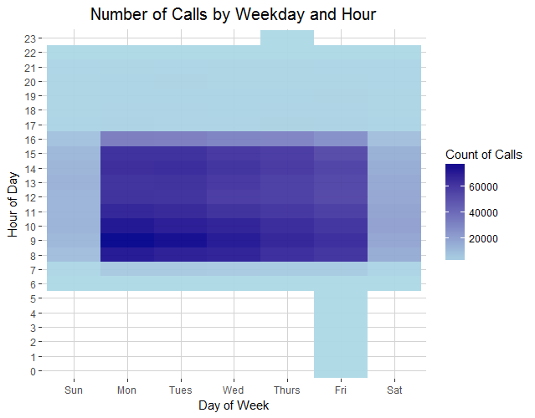

Figure 3.1.3 Number of Calls by Weekday and Hour

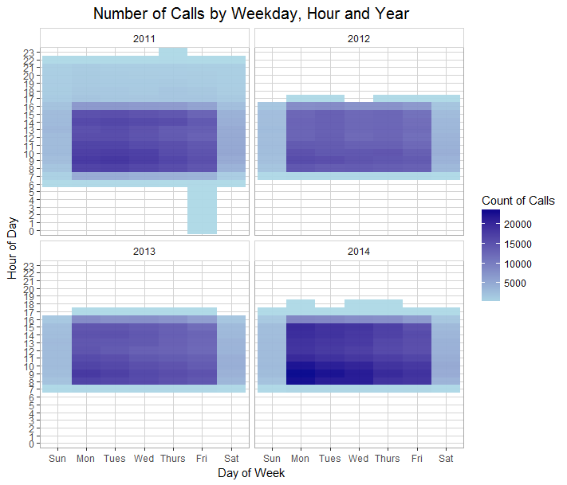

Figure 3.1.4 Number of Calls by Weekday, Hour and Year

Figure 3.1.3 is a heatmap that shows the distribution of calls by hour of day and day of week. A majority of calls are received between 8:00-11:00 a.m. and 2:00-3:00 p.m., especially Mondays through Wednesdays. However, many calls were received outside working hours – between 0:00-7:59 a.m. and from 5:00-11:00 p.m..

When we add a ‘year’ dimension to the graph (Figure 3.1.4), it is noticable that almost all those outliers occur in 2011. After filtering the dataset and doing research, we conclude that those between 6:00-8:00 a.m. and 5:00-11:00 p.m. are due to extended call center hours, while those from midnight to 6:00 a.m. are due to the Windstorm on Dec. 1st that knocked out power from Thursday night to Friday morning.

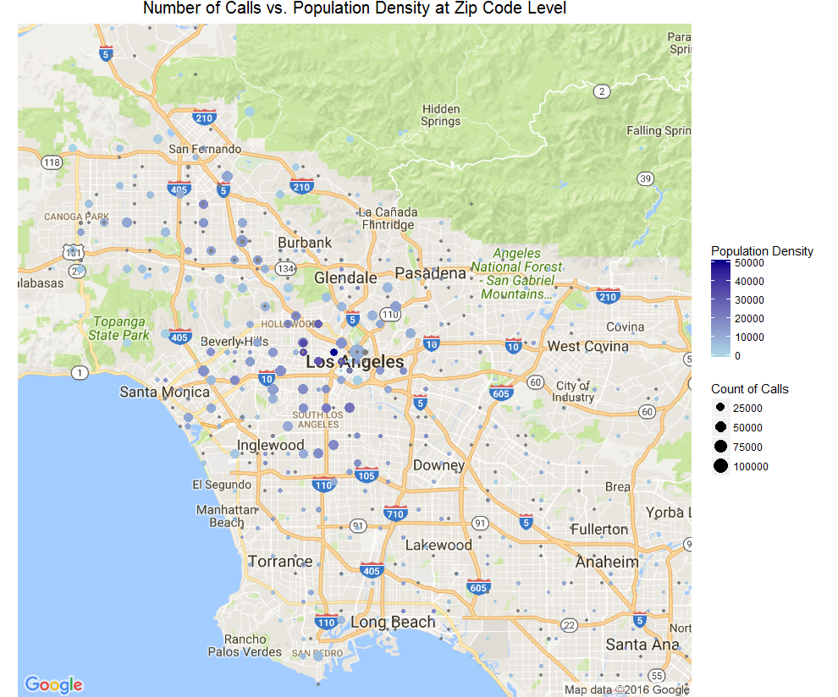

Figure 3.1.5 Number of Calls vs. Population Density at Zip Code Level

Figure 3.1.5 maps the number of calls and population density at each Zip code, where darkness of color represents population density and size of dot represents count of calls. As depicted in the graph, there appears to be no obvious correlation between the population density of a given Zip code and the number of calls received in the area. However, we can see that a majority of the calls look to be clustered around Central and South Los Angeles.

### Resolution Categories

We categorized all calls into six categories, based on call resolution in the data:

|  |  |
| --- | --- |
| Resolution Category | Sub-Categories of Call Resolution in the Dataset |
| Handled | Call Resolution, Gave Caller Information, Service Request Processed |
| Referred | Referred to 411, Referred to County, Referred to Other Governmental, Referred to State |
| Transferred | Transfer (City), Transferred to 411, Warm Transfer (City) |
| Escalated | Escalate to Supervisor, Escalated to Office of Finance |
| Service Failure | Got Voicemail (City), Info Not Available (Non-City), Line Busy (City) |
| Other | Static/Ghost Call, Caller Hung Up, N/A |

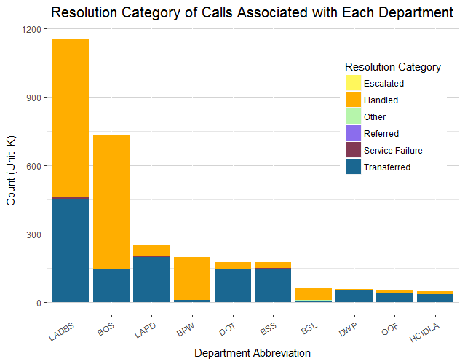

Figure 3.1.6 Resolution Category of Calls Associated with Each Department

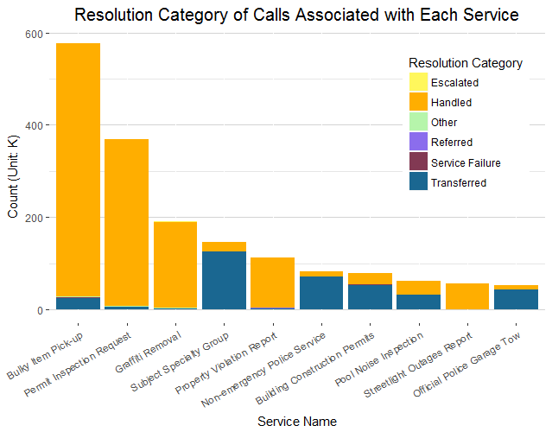

Figure 3.1.7 Resolution Category of Calls Associated with Each Service

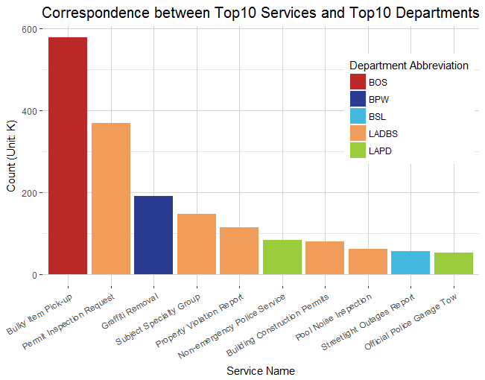

Figure 3.1.8 Correspondence between Top10 Services and Top10 Departments

Figure 3.1.6 and 3.1.7 describe resolution category of calls associated with each department and service. In Figure 3.1.6, it appears that some departments have relatively high number of transferred calls, such as LADBS (Department of Building and Safety), LAPD (LA Police Department), DOT (Department of Transportation), and BSS (Bureau of Street Services). This can be explained by the type of services the departments solve. For example, according to Figure 3.1.8, LADBS solves 5 out of the top 10 most frequently requested services, including permit inspection request, subject specialty group, property violation reports, building construction permits, and pool noise inspection. Among the 5 types of services, subject specialty group, building construction permits, and pool noise inspection have extremely high transfer rates (Figure 3.1.7), which contributes to the overall high transfer rate of LADBS.

### Service Failures

When we look at service failures in Figure 3.1.9, not surprisingly, service failures are more likely to occur during office hours. LAPD (Los Angeles Police Department), DWP (Department of Water and Power), and DOT (Department of Transportation) have similar call and service failure volumes, and are busiest at the most diverse hours. In addition, LADBS has the highest number of failed services, due to the fact that it also has the highest volume of calls and service failures.

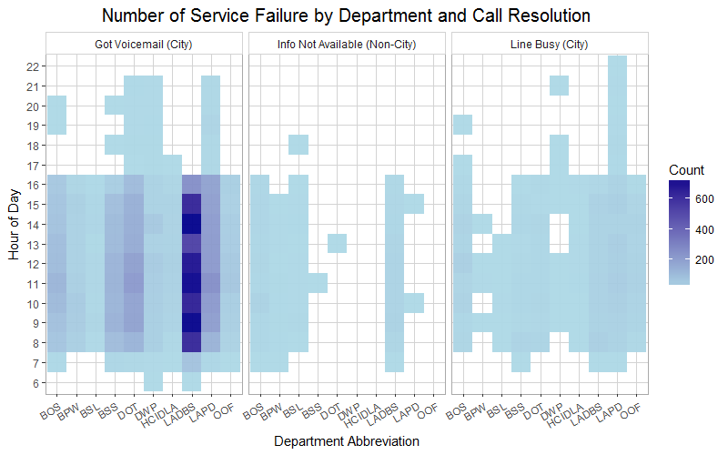

Figure 3.1.9 Number of Service Failure by Department and Call Resolution

### Correspondence between Area and Service

Below, figure 3.1.10 shows correspondence between the top 20 zip code areas and the top 10 services. Area 90012 (Chinatown) has highest number of requests, followed by 91606 (North Hollywood), 90026 (Silver Lake and Echo Park), and 90042 (Highland Park). The main findings from the graphs are as follows:

* 90012 (Chinatown) has a relatively large number of calls related to non-emergency police service, building construction permits, as well as report of property violation. The reason why it appears is that population density in the area is relatively large, and the majority of household are rented in the area.
* 91606 (North Hollywood) has a large number of calls related to bulky item pick-up.
* 90042 (Highland Park) has a higher number of calls associated with graffiti removal, probably due to high percentage of young adults in the area.
* 90025 (West LA) has much more calls associated with pool noise inspection than any other areas, which might be result of affluent demographic in the area.

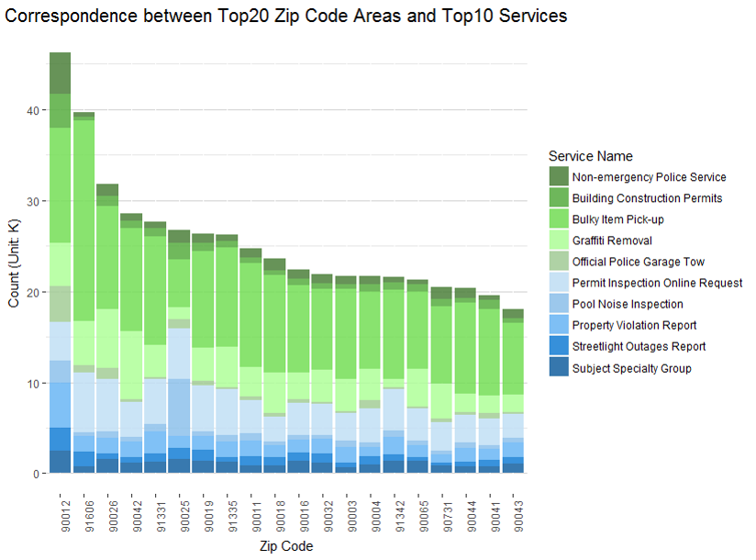

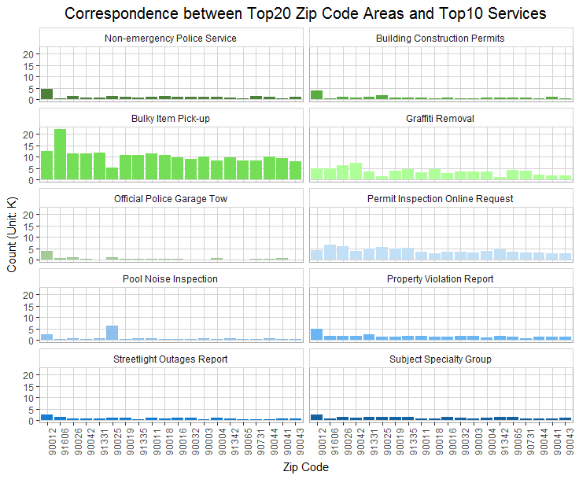

Figure 3.1.10 Correspondence between top20 zip code areas and top10 services

## 3.2 MyLA 311 Request Data

### Request Type

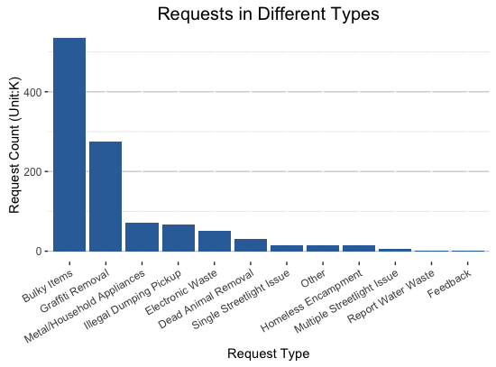

Figure 3.2.1 Request in Different Types

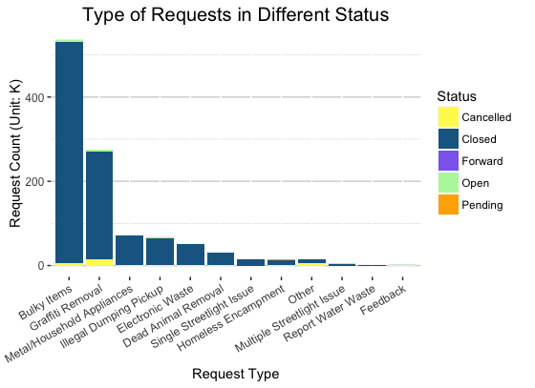

Figure 3.2.2 Type of Requests in Different Status

Graph 3.2.1 gives us the basic descriptive statistics analysis with Request Types and the count of requests in a descending order via a bar chart. The top 3 types of requests are Bulky Items, Graffiti Removal, and Metal/Household Appliances. In the next graph (3.2.2), we add the variable of Status into the graph with different colors in each bar to take a better look of the progress with each case. We can see from this graph that the majority status in all request types are closed, which reflects the efficiency of the officers.

### Request Status

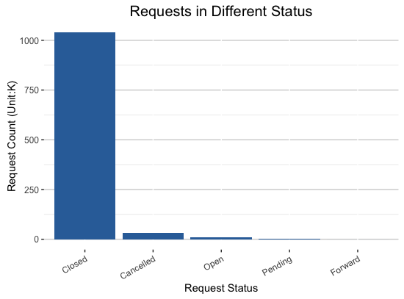

Figure 3.2.3 Requests in Different Status

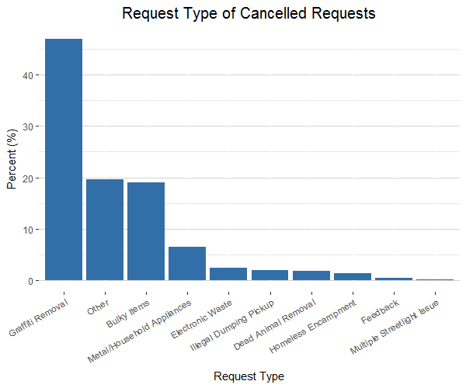

Figure 3.2.4 Request Type of Cancelled Requests

Through Figure 3.2.3, we can see almost all the requests are closed. Because of the in detail in how requests are entered, rarely are requests forwarded, which is a very good sign for efficiency. As shown in Figure 3.2.4, graffiti removal is the most cancelled request at 45% of all cancellations. This may be due to multiple people reporting the same graffiti.

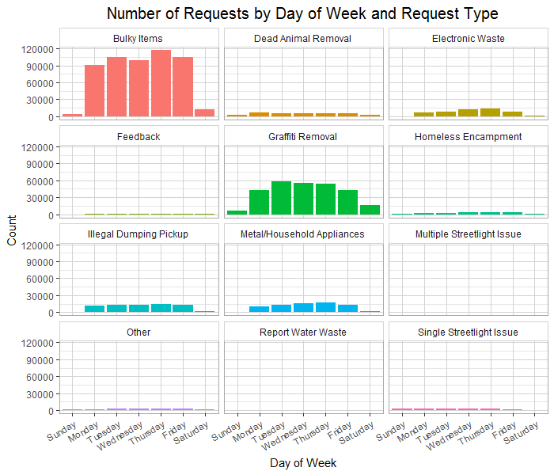

Figure 3.2.5 Request Type by Day of Week

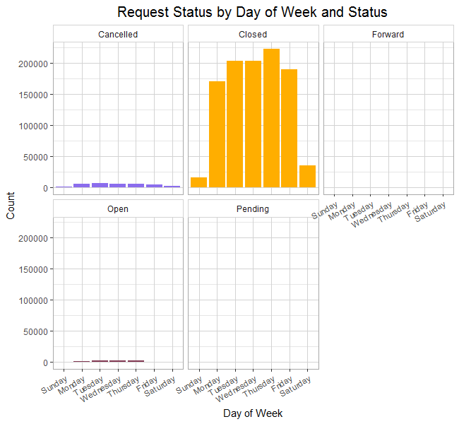

Figure 3.2.6 Request Status by Day of Week

What we tried to do was to find a pattern in requests for the days of the week, but, as shown above in Figures 3.2.5 and 3.2.6, there was not any major pattern for any requests. Throughout the week, all requests are very sporadic. We could also assume that more requests were opened earlier in the week (because of the weekend), but there was also not much evidence supporting this, so we need to do more analysis to dig further into that.

### Request Owner

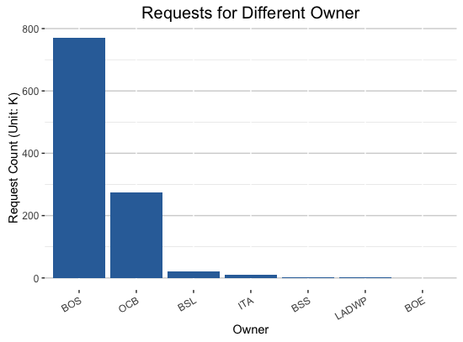

Figure 3.2.7 Requests for Different Owners

According to Figure 3.2.7, the Top 3 requests for Different Owners are BOS, OCB, and BSL, which corresponds to the results we got from Tracking data. BOS (Bureau of Sanitation) is the department in charge of removal of bulky items, which explains why this department is in greatest need.

### Request Source

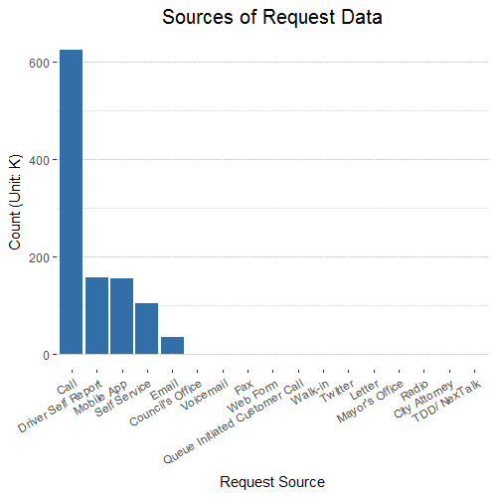

Figure 3.2.8 Sources of Request Data

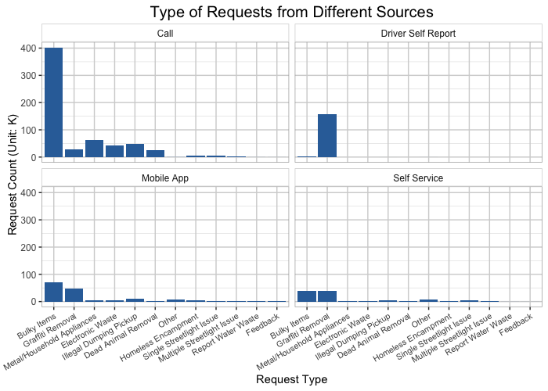

Figure 3.2.9 Type of Requests from Different Sources

According to Figure 3.2.8 and 3.2.9, there are plenty of sources to make a request. The top 3 popular sources for people to make a request are Call, Drive Self Report, and the Mobile App. What we find interesting is that, the most common way for people to make a request is simply to call the center, and the services are various in different request types. But when it comes to Graffiti Removal, Driver Self Report has the majority of the requests. When it comes to the type of Bulky Items, people tend to make calls, which seems like the easiest way to get the giant stuff removed.

### Administration Area

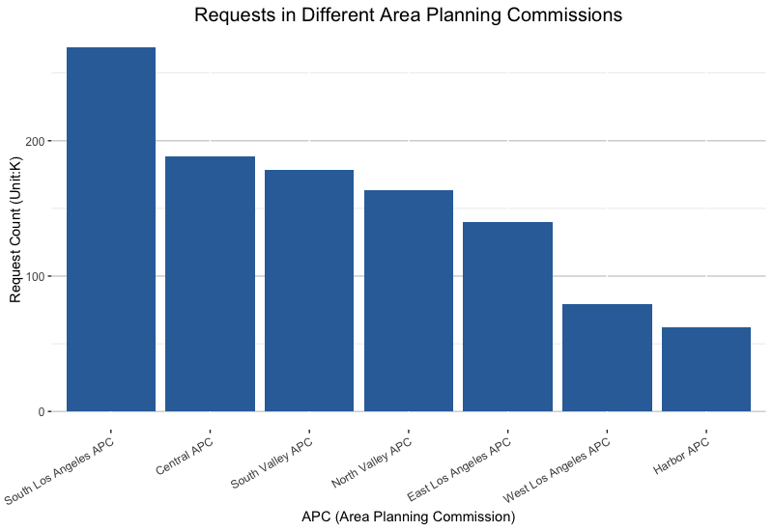

Figure 3.2.10 Requests in Different Area Planning Commissions

Figure 3.2.10 indicates that the top three APCs which generate the most requests: South LA, Central, and South Valley APC.

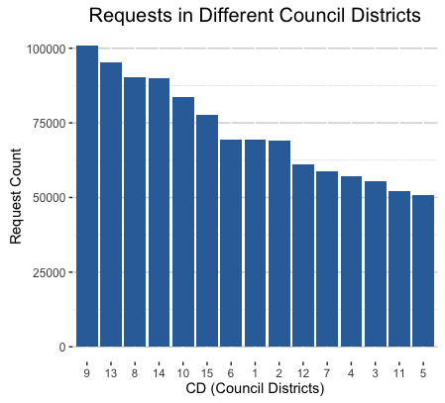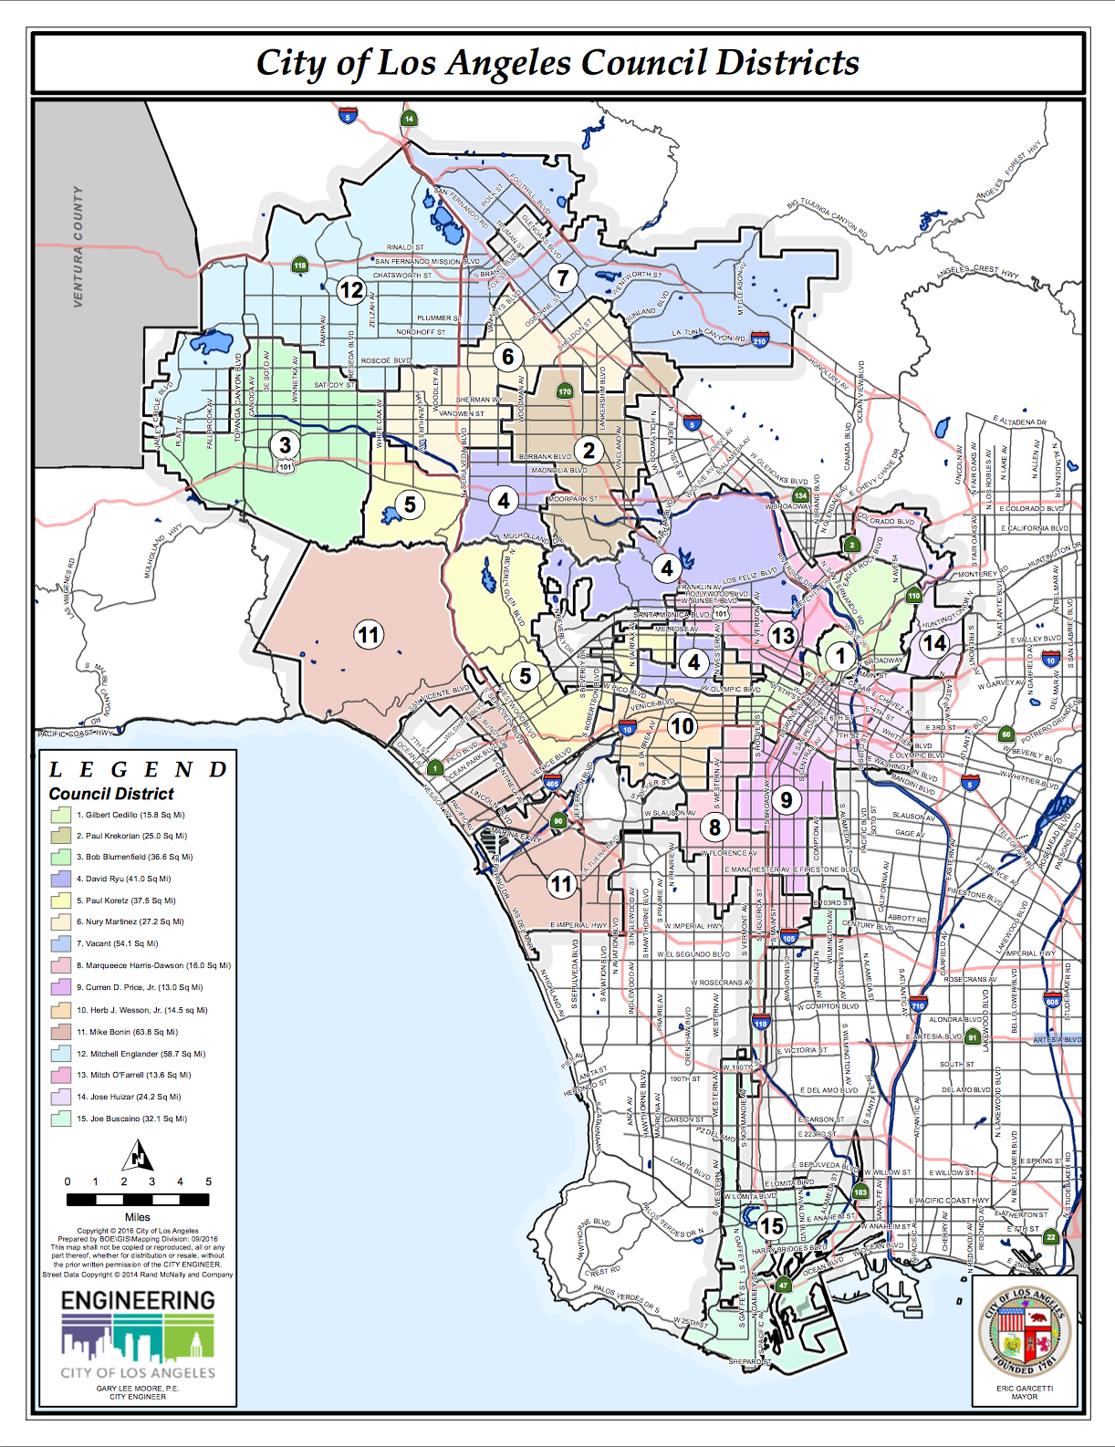

Figure 3.2.11 Requests in Council Districts and Los Angeles Council District Map

Based on the map of Los Angeles Council Districts above, the Council Districts that have most requests like 9, 13, 8 are somewhere in the south Los Angeles, which can draw the identical conclusions about the Administration Area (Council Districts & Area Planning Commission) VS. requests that South Los Angeles sees most requests.

### Top ZIP Code Areas

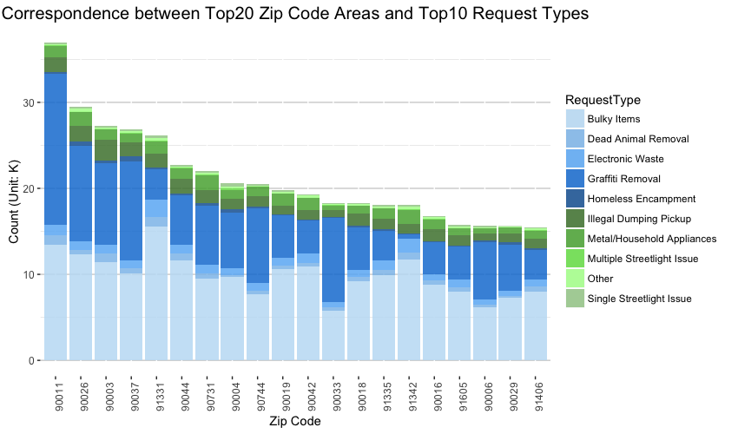

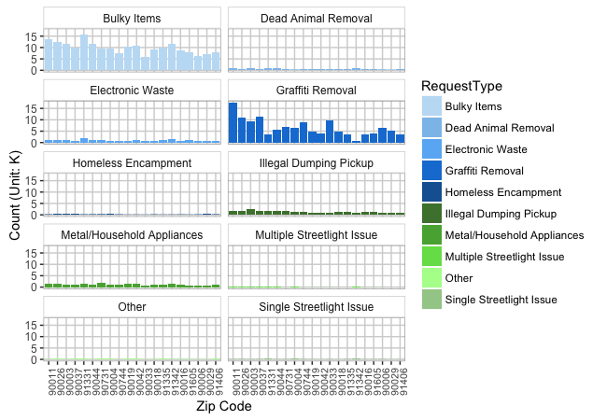

Figure 3.2.12 Correspondence between Top20 Zip Code Area and Top10 Request Types

The two graphs above (Figure 3.2.12) show the different requests showing in top 20 zip codes. We’ve got several interesting findings regarding the zip codes and different type of request:

* Abnormally large amount of requests of Bulky Items and Electronic Waste in zip code 91331: Pacoima. Pacoima “has an extremely large population density”, quote from [www.unitedstates**zipcodes**.org/**91331**/](http://www.unitedstateszipcodes.org/91331/)
* Abnormally large amount of requests of Graffiti Removal in zip code 90011: Central Alameda. “ZIP code 90011 is located in south California and covers a slightly less than average land area compared to other ZIP codes in the United States. It also has an extremely large population density. The people living in ZIP code 90011 are primarily another race. The number of people in their late 20s to early 40s is extremely large while the number of young adults is large. There are also an extremely large number of single parents and an extremely small number of single adults. The percentage of children under 18 living in the 90011 ZIP code is extremely large compared to other areas of the country”, quote from <http://www.unitedstateszipcodes.org/90011/>

### Heatmap and Population Density Maps

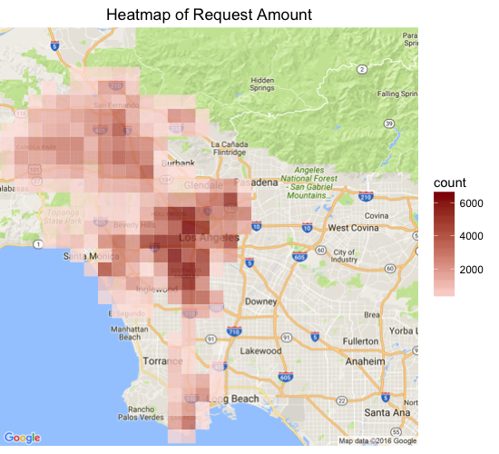

Figure 3.2.13 Heatmap of Request Amount

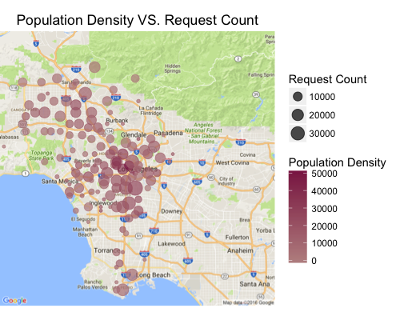

Figure 3.2.14 Population Density and Request Count of Zip Code Areas

We combined the data of Population Density in Los Angeles into our analysis to examine whether there is a correlation between population density and requests in different areas.

It appears that requests happened most in the Central LA, South LA and Korean Town, and in general, the higher the population density, the larger the number of requests.

# Recommendation and Conclusion

Based on analysis above, our conclusion and recommendations are as follows:

* The busiest departments include LADBS, LAPD and BOS, which deal with the most number of calls/requests but also have relatively high number of service failures. Similarly, DWP and DOT experience calls failures at more diverse hours than other departments, which is likely because water, power and transportation issues are the most urgent for citizens of Los Angeles. Therefore, it is recommended that City of Los Angeles sets dedicated hotlines for frequently called departments to reduce service failures.
* We also suggest City of Los Angeles to pay attention to potential needs of certain types of services of individual neighborhoods, and plan for city infrastructures and facility construction accordingly.
* The number of service requests submitted through mobile app is much less than those submitted via phone calls. The city should encourage use of mobile app in order to save labor work and improve work efficiency.